Lab report 03

**307L-MBSD LAB**

**Department of Computer System Engineering**

**University of Engineering and Technology Peshawar**

Submitted to: **Engr. Shahzada Fahim Jan**

Submitted by:

**DCSE, Batch 23, Section “B”**

**Lab 03**

**Interfacing Push buttons to 8051 Development kit using Polling**

**Objective:**

* To learn to interface buttons and LEDs to 8051 ports.
* To learn how polling works in 8051 Micro-controller.

**Components needed for this lab:**

* Keil µVision IDE
* Proteus Software
* 8051 Micro-controller

**Tasks:**

**Task 1:** Complete all the tasks given in the slides.

#include <reg51.h>

#include <stdio.h>

sbit led1 = P1^0;

sbit switch1 = P2^0;

void main(void)

{

int i = 0;

for(;;)

{

if(switch1==0)

led1=1;

else if(switch1==1)

led1=0;

}

}

8051 C Code for switching light on and off with polling

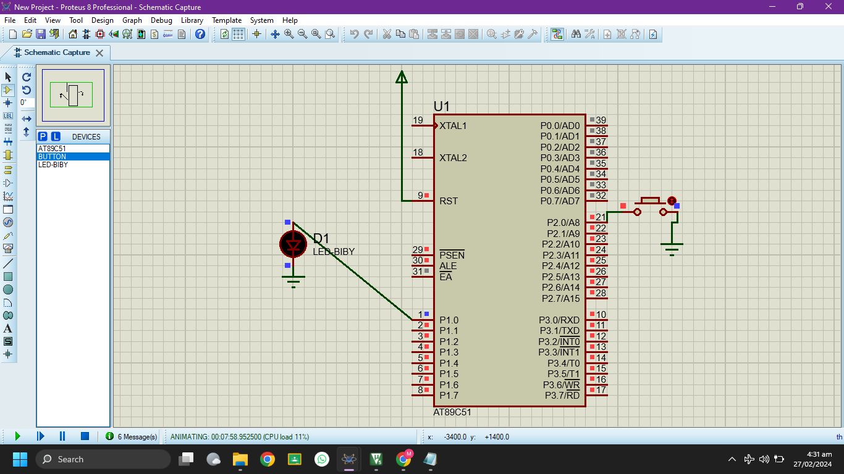

Fig 02: LED is OFF when button is not pressed

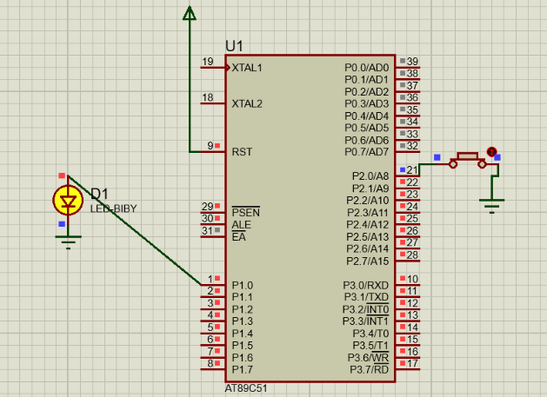

Fig 03: LED turns on when button is pressed

___________________________________________________________________________________________________________

**Task 2:** Two Switches with three LEDs.

#include <reg51.h>

#include <stdio.h>

sbit led1 = P1^0;

sbit led2 = P1^1;

sbit led3 = P1^2;

sbit led4 = P1^3;

sbit switch1 = P2^0;

sbit switch2 = P2^1;

void main(void)

{

int i = 0;

for(;;)

{

if(switch1==0 && switch2==0){

led1=0;led2=0;led3=0;led4=1;

}

else if(switch1==1 && switch2==0){

led1=0;led2=0;led3=1;led4=0;

}

else if(switch1==0 && switch2==1){

led1=0;led2=1;led3=0;led4=0;

}

else if(switch1==1 && switch2==1){

led1=1;led2=0;led3=0;led4=0;

}

}

}

\

C Code

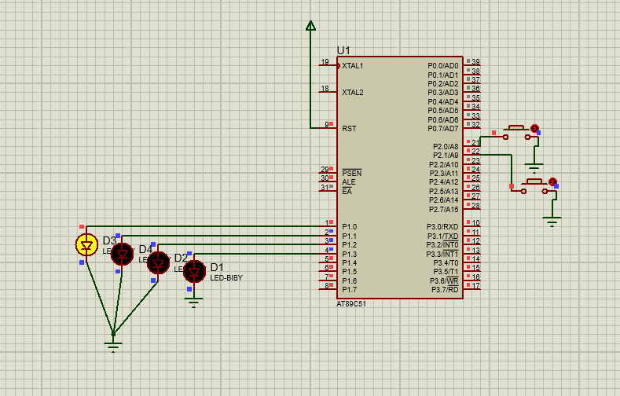

Fig 04: First LED is glowing on 00

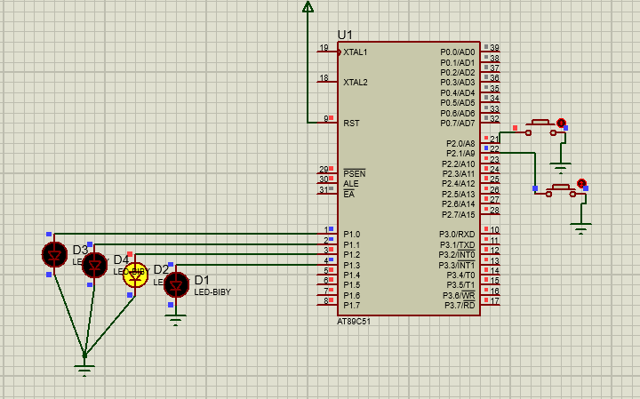

Fig 05: Third LED is glowing at 10

____________________________________________________________________________________________________

**Task 3:** Attach 3 push button with PORT2 and 8 LED’s with PORT1 and turn ON led when the corresponding button are pressed, use polling for monitoring the buttons

#include <reg51.h>

sbit led1 = P1^0;

sbit led2 = P1^1;

sbit led3 = P1^2;

sbit led4 = P1^3;

sbit led5 = P1^4;

sbit led6 = P1^5;

sbit led7 = P1^6;

sbit led8 = P1^7;

sbit switch1 = P2^0;

sbit switch2 = P2^1;

sbit switch3 = P2^2;

void main(void) {

while (1) {

if(switch1==0 && switch2==0 && switch3==0)

{ P1=0x00; led1=1;}

else if(switch1==0 && switch2==0 && switch3==1)

{ P1=0x00; led2=1;}

else if(switch1==0 && switch2==1 && switch3==0)

{ P1=0x00; led3=1;}

else if(switch1==0 && switch2==1 && switch3==1)

{ P1=0x00; led4=1;}

else if(switch1==1 && switch2==0 && switch3==0)

{ P1=0x00; led5=1;}

else if(switch1==1 && switch2==0 && switch3==1)

{ P1=0x00; led6=1;}

else if(switch1==1 && switch2==1 && switch3==0)

{ P1=0x00; led7=1;}

else if(switch1==1 && switch2==1 && switch3==1)

{ P1=0x00; led8=1;}

}

}

Fig 06: After Building we Start Debug Session

C code for 8 LED and 3 switches

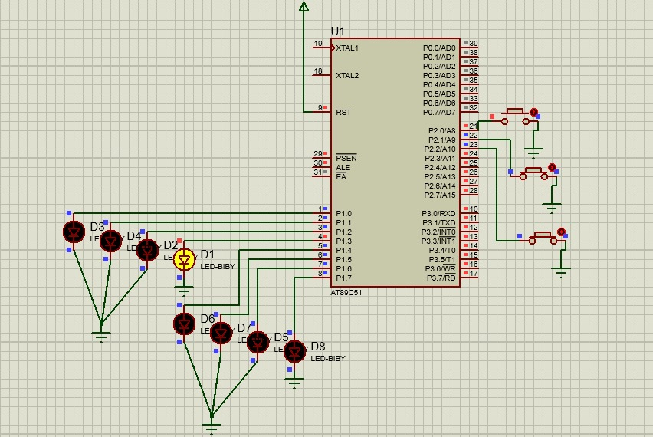

Fig 06: Corresponding LED is glowing

**____________________________________________________________________________________________________________________________**